**BIT LEVEL 300(GROUP A)**

**VISUAL BASIC PROJECT ON A HOSTEL MANAGEMENT SYSTEM**

**GROUP MEMBERS**

**SOLOMON BAMIEBO –** 040916565  **SHDRACK STONE–** 040916562

**DEKU STEPHEN KWABLA JNR. –** 040916251

**NAME PASSWORD**

Admin 0000

User 1234

**INTRODUCTION**

Technology is one of the basic things we use on an everyday basis. Every manual system is being automated which saves everyone a lot of time. There have been various attempts at simplifying hostel management. From numbering systems, guard posts, log books and more. These work fine but have very huge loopholes in their operation.

Taking the example of log books into consideration; it is a simple way of keeping records but lacks security and leaves visitor information open to anyone’s access. A Hostel Management System would provide a better and more efficient level of security. With this Hostel Management System, the staff or whoever is assigned to handle the system is the only one who can register residents, check in visitors and more. Other administrative tasks are taken care of by this system which would make the entire operation of the hostel much more efficient.

**BACKGROUND**

Making registration process for a hostel as simple as possible is the major concern here while trying to improve security. Also ensuring proper allocation of rooms and making sure visitors and other non-residents are accounted for to help improve security. Registration process is usually quite stressful since its done manually i.e. by use of a logbook which usually causes major errors in the hostel’s operations. This system would ensure the right time of entry and exit on the part of visitors is as accurate as possible. There would be no redundancy of data. The data can be stored in the computer’s secondary memories like hard disk, etc. so it can be easily retrieved and used at any time.

Should there be the case of a robbery of anything along that line the system would give very accurate records as to who aside the occupants of the rooms was in there at whichever time.

**PROBLEM STATEMENT**

Allocation of rooms is usually done by use of logbooks which would cause some sort of traffic should there be a large number trying to register on the same day. With the case of registration via logbooks, the likelihood of a mix up is even higher due to simple human errors. In the case of visitors, the system would be able to record the accurate time at which the visitor came in and when he/ she left should there be the case of a robbery or anything along that line, tracing who was present at the time would be easier and more efficient which is unlikely with the use of basic logbooks. While logbooks are perceived to be easier and more convenient, their use is a risk to the security of visitors who sign in since their details are available for any and every one to access.

**SOLUTION**

**System Specification.**

The goal is to develop a system that can be used by the average individual should they be assigned the task of managing this system.

* The system was made to be a stationary one which would best of optimum usage should it be on two separate computers; one for the receptionist and one for the administrator or manager of the hostel.
* A functional computer which meets average standards should suffice in delivering what the system is intended to achieve. Internet connectivity would be an added bonus since it is not exactly top requirement for the system to be able to function as it should. These aside, stable supply of power i.e. electricity is crucial to ensure the system is up and running at all times which would in turn ensure there is barely a chance of data loss.
* A good database is essential to the smooth running of the system. Access was used in the creation of this system’s database.
* A backup drive or cloud storage would be necessary to ensure that no matter what happens there is no chance of data loss which would or could make a mess of the system’s entire operation process.

**System Requirement.**

* The system would allow easy assignment or allocation of duties on the part os the hostel’s employees. They would be easily reachable since their contact details would be stated and shared with the residents of the assigned room to ensure someone is accountable for anything that should happen in the absence of the residents.
* The database would serve as a reminder or record book to help with crosschecks and other delicate issues which would require records and what not. The database would also help should it be backed up so in case of anything retrieval of data would not be another headache on its own.
* The system os intended to make registration of hostel accommodation less stressful compared to how it is now. Due to time markers, we know which entry was made first should there be a confliction of some sort.

ERD

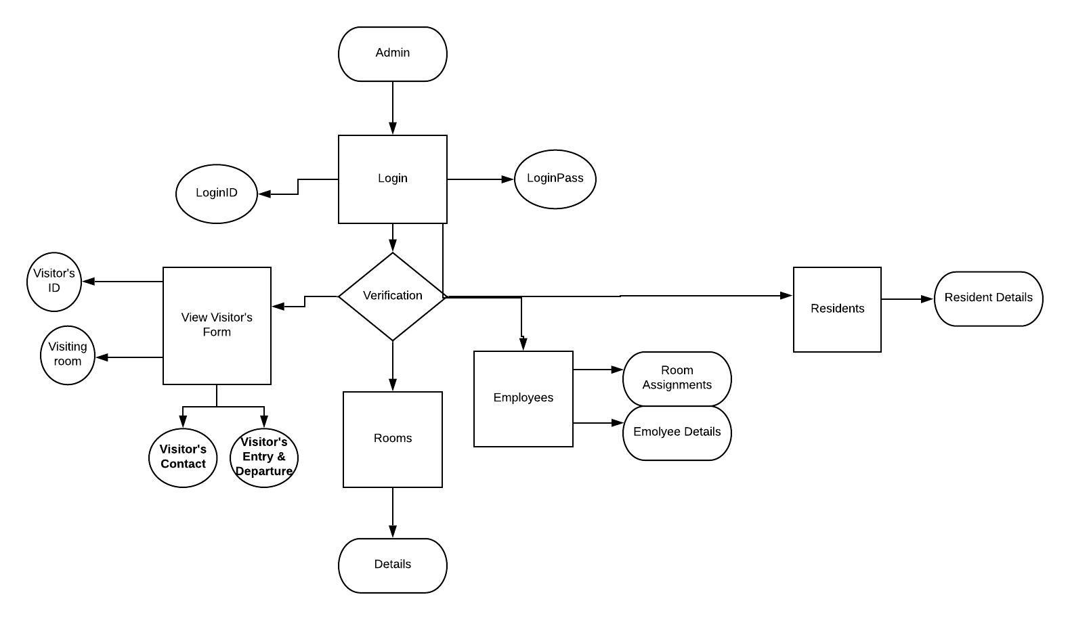

**DESIGN**

This section of the documentation describes how the software was designed. The design phase gave us the foundation for actual programming. From the analyzed data, there was a need for a login window form that enables the user to be authenticated and verified that person before the main page pops up. The login window presents the user the opportunity to create his/her login credentials. It has a general page format for entering data into the system, and a database that houses all the information.

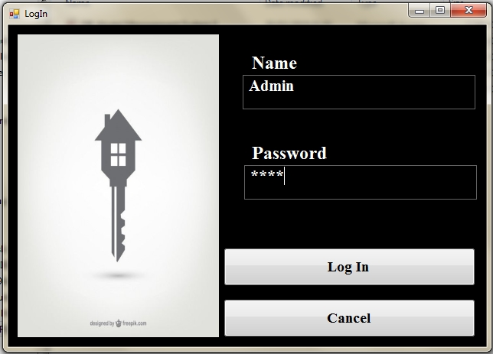

**Figure 1.0**

The Login form was made using two text boxes which receive information inputted by the user. The text boxes have individual Labels to guide the user as to where to enter which data.

A Button by name “Login” is also included which accepts the login credentials which would be inputted. It simply cross checks the database for users that have been granted access by the admin. If everything should check out the user would be able to access the system.

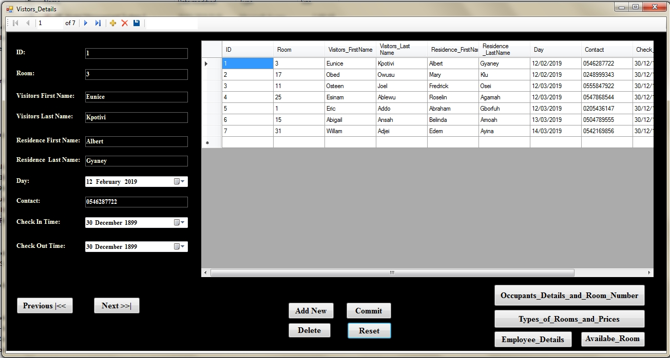

**Figure 2.0**

The Visitors’ form would be the most used form within the system so it just makes sense for it to be the first thing you see. This form contains a table which accepts the visitor’s name, contact, the room they’ll be visiting along with the time at which they entered and exited. The plus side of this is the ability of the system to read the computer’s exact time giving very accurate recoeds. Buttons that lead to other forms for easy navigation are also available within this form along with a “save” and Reset” button.

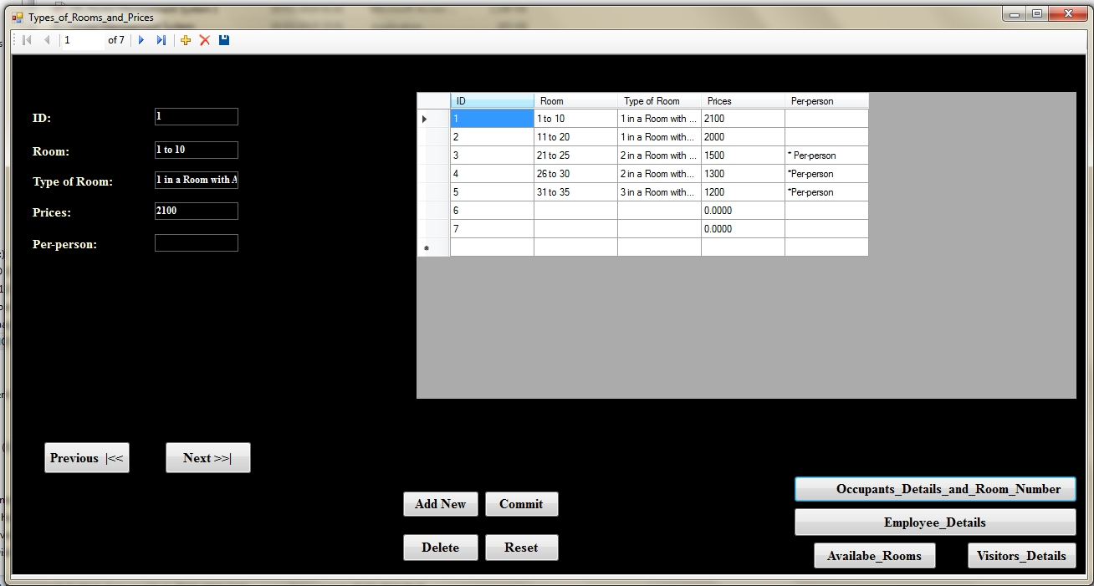

**Figure 3.0**

The Room Type form displays the type of rooms the hostel has along with their capacity and their individual prices. This is basically the menu for the hostel. Buttons leading to other pages making navigation much easier.

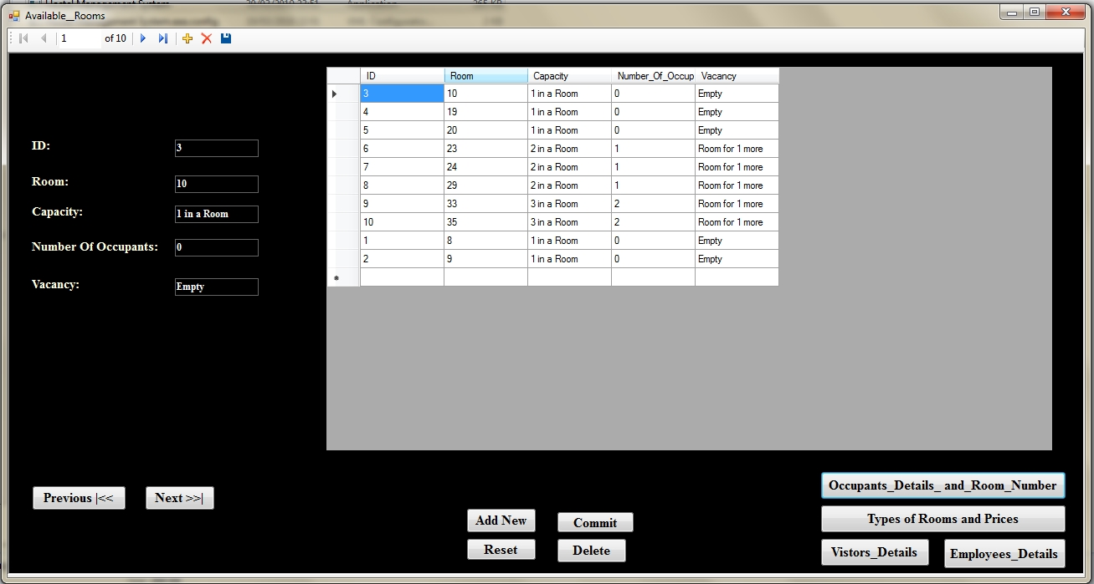

**Figure 4.0**

This form displays the available rooms, the capacity and if there is vacancy in the given room. Textboxes within the form allow for edits to be made to the available rooms as and when someone books it. Buttons linking the pages makes navigation as easy as it gets to ensure effective and time efficient processes.

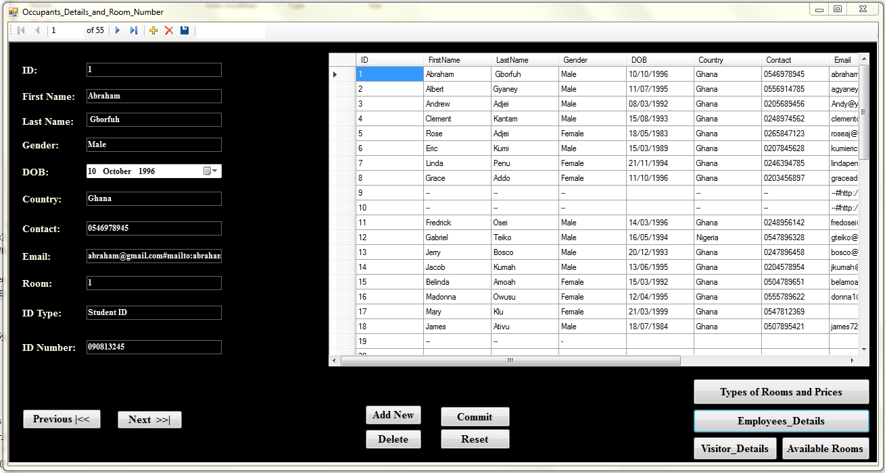

**Figure 5.0**

Next is the Occupant’s Form which contains information about the residents of the hostel along with whichever room they might be in. Text boxes within the form allow for edits to be made to the information available as and when changes are made to it.

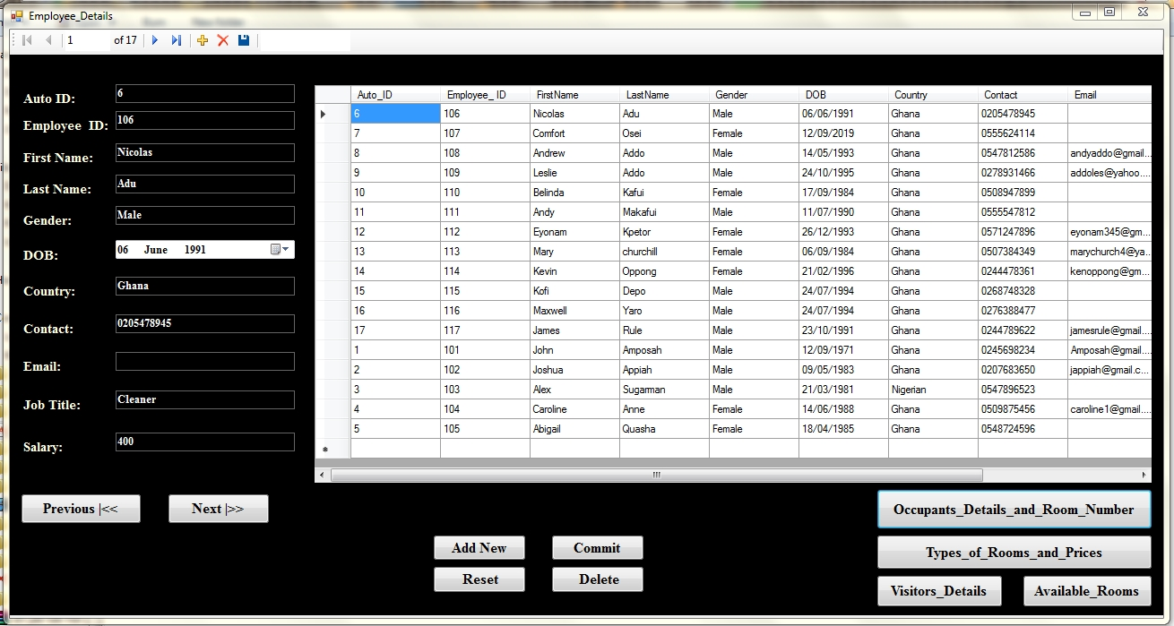

**Figure 6.0**

This form shows a list of employees the hostel has on hand and their various assignments. It contains information of the time at which they should have been working in whichever room and what time they leave. Their contact details are also available in case of anything.

**HOW THE PROBLEM WAS SOLVED**

The system of this complete project was built with visual basic, with an interface session where users interact with the system and code behind the scenes that keeps the project running should all system requirements be met. The system was specifically built to address the shortfall and loopholes in the collecting of information of hostel residents and visitors alike, it was designed taking all the various stakeholders of the system’s views into consideration during the design process. The major stakeholders of the system are hostel managers, receptionists and residents or visitors of the hostel. The system is designed in a way that ensures all basic activities that are required in the day to day running of a hostel are simplified with time saving being the major factor. The system does not require any advanced expertise and knowledge before one can use it, and also it is a very simple one that an average person can manipulate.

We took a survey on The University of Ghana Campus since it hosts a larger number of hostels which would provide us with as much information as possible. We took information from both the students/residents, hostel registrars and the security personnel assigned with signing in and out all visitors. With the information provided we then worked out the flow of information within the system using ERDs and more. For effective and flawless data, survey and interview methods were extensively used. Survey method is the most extensively used technique in collection of data collection in science while interviews are an appropriate method to use when seeking the customer or participants perspectives due to the qualitative nature of information it provides. These methods have been widely used to extract the most relevant information and helped in better analysis of data. In order to efficiently use the survey method, we engaged the participant and stakeholders in interview sessions. The interview was intricately designed to measure the success rate of this application.

**Conclusion.**

For many years the student population has increased immensely which means the demand for hostel accommodation would only increase which is why there is a need for improvements to be made and without the necessary changes being made to the running of such institutions, there will always be major problems which would cost a lot more.

This system would prove to be immensely effective in the day to day running of the hostel with little to no issues at all.

Despite facing numerous challenges in the creation of this project, through hard work and numerous tutorial videos we were able to accomplish thus